As setup is prepared (PC/Laptop is connected to the gateway using Micro USB, COMport slot is on the slot of the SIM Card, TeraTerm is installed and running), please follow these steps:

1. Navigate to **File → Click new connection**
2. Choose **Serial** as Connection type.
3. Choose correct COM port and click on the OK button.

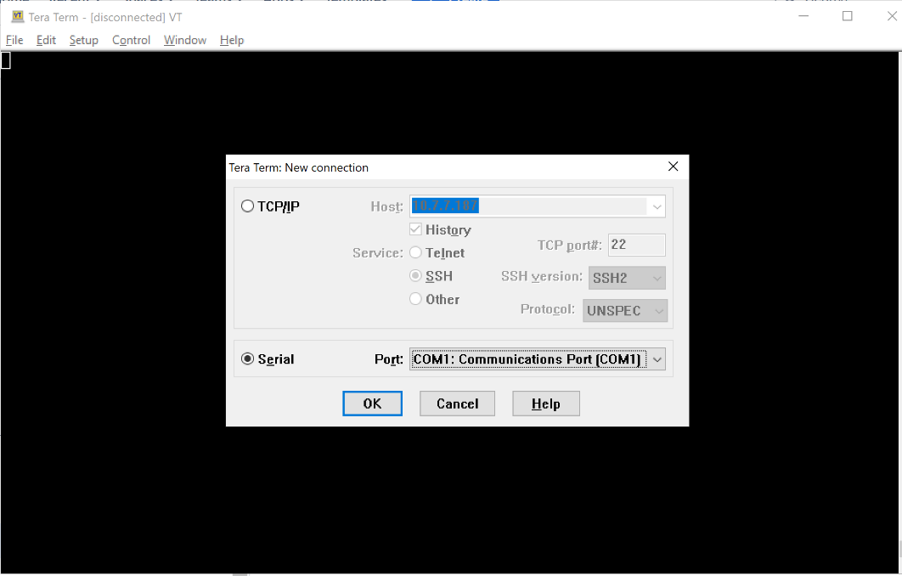

1. Navigate to **Setup** -> **Serial port**
2. Change COM port to the desired and set baud rate to "**115200**"

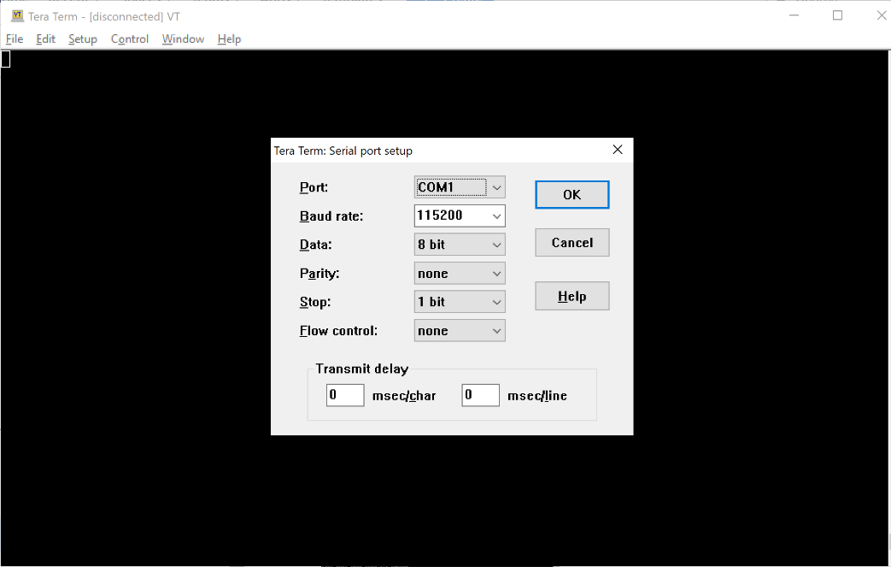

1. Click OK to apply the new setup.

Procedure to delete gateway`s password:

1. Power cycle the gateway by unplugging the power cable and plugging it back.
2. Hit "Z" ('Shift+z' or turn on the Capslock and press 'z') when the "**Press 'Z' to stop autoboot**" message appears during bootup to stop the autoboot.
3. Execute the below command to boot into recovery partition: run recoveryboot
4. In recovery terminal run: recover
5. Then select option 4.
6. Type the command: passwd -d root
7. Type: exit
8. Run the command: reboot

At this moment, password is removed from the gateway.

To setup new password, use regular SSH connection via ssh [root@ip.of.the.gateway](mailto:root@ip.of.the.gateway)

1. As connection with the gateway is established, execute the following command: Passwd

Type new password. Confirm new password.